RESOLUTION NO.__________

RE: CERTIFICATE OF APPROPRIATENESS UNDER THE
PROVISIONS OF THE ACT OF THE PENNSYLVANIA
LEGISLATURE 1961, JUNE 13, P.L. 282 (53
SECTION 8004) AND BETHLEHEM ORDINANCE NO.
3952 AS AMENDED.

The applicant proposes to add a 6’ lattice fence in the back yard, replace wood bilco doors with metal locking bilco doors and change paint color on bottom of shutters and bottom half of the side porch at 30 E. Wall St.

NOW, THEREFORE, BE IT RESOLVED by the Council of the City of Bethlehem that a Certificate of Appropriateness is hereby granted for the proposal.

Sponsored by: (s)

(s)

ADOPTED BY COUNCIL THIS DAY OF

(s)
President of Council

ATTEST:

(s)
City Clerk

HISTORICAL & ARCHITECTURAL REVIEW BOARD

The applicant proposes to add a 6’ lattice fence in the back yard, replace wood bilco doors with metal locking bilco doors and change paint color on bottom of shutters and bottom half of the side porch at 30 E. Wall St.

APPLICATION #8:

Christian Barrett
30 E. Wall St.
Bethlehem, PA 18018
OWNER:

__________________________________________________________________________

The Board upon motion by Gen Marcon and seconded by Marsha Fritz adopted the proposal that City Council issue a Certificate of Appropriateness for the following:

- Install a new 6’ high lattice topped cedar fence along the rear property lines.

2. Install a painted metal Bilco type door on the rear basement stairs.

3. Paint front shutters, door trim, brick bottoms courses and porch rim boards in
Roycroft Pewter.

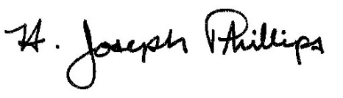 By:__H. Joseph Phillips___________

Title: __Historic Officer____________

Date of Meeting: November 7, 2018

